PYTHON DA END ASSIGNMENT - PYTHON

MARKETING CAMPAIGN PERFORMANCE INSIGHTS

TOOLS: Python / VS Code

PROJECT TITLE: Python DA - Marketing Campaign Performance Insights

PROJECT OBJECTIVE: To clean, analyze, and visualize multi-channel marketing campaign data using Python, Matplotlib, and Seaborn to identify key drivers of Campaign ROI, evaluate channel effectiveness, analyze customer segment performance, and optimize acquisition cost and conversion rates across different geographic locations and demographics.

DATE OF SUBMISSION: 11/11/2026 – 8:45 PM
PROGRAMMING FILE NAME - “Python Data Analysis Marketing Campaign
Performance Insights.py”
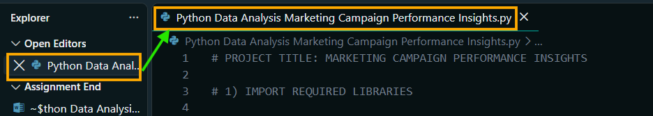
1) IMPORT REQUIRED LIBRARIES
# 1) IMPORT REQUIRED LIBRARIES

import numpy as np
import pandas as pd
import matplotlib.pyplot as plt
import seaborn as sns

sns.set_theme(style="whitegrid")

2) LOAD THE DATASET
2.1) LOAD THE DATASET FROM THE PROVIDED URL
# 2.1) Load the dataset from the provided URL
url = "https://raw.githubusercontent.com/ArchanaInsights/Datasets/main/marketing_campaign.csv"

df = pd.read_csv(url)

print("\n========== DATASET LOADED SUCCESSFULLY ==========\n")
print(df.head())

3) BASIC DATA EXPLORATION
# 3) BASIC DATA EXPLORATION

print("\n========== FIRST 5 ROWS ==========\n")
print(df.head())

print("\n========== NUMBER OF ROWS AND COLUMNS ==========\n")
print(df.shape)

print("\n========== COLUMN NAMES ==========\n")
print(df.columns)

print("\n========== DATA TYPES ==========\n")
print(df.dtypes)

print("\n========== DATASET INFORMATION ==========\n")
df.info()

print("\n========== DESCRIPTIVE STATISTICS ==========\n")
print(df.describe())

4) UNIQUE VALUES AND CATEGORY COUNTS
4.1) CHECK FOR UNIQUE VALUES IN KEY COLUMNS
# 4.1) Check for unique values in key columns
print("\n========== UNIQUE CAMPAIGN IDs ==========\n")
print(df['Campaign_ID'].nunique())

print("\n========== UNIQUE LOCATIONS ==========\n")
print(df['Location'].unique())

print("\n========== UNIQUE CUSTOMER SEGMENTS ==========\n")
print(df['Customer_Segment'].unique())

print("\n========== CAMPAIGN TYPE COUNTS ==========\n")
print(df['Campaign_Type'].value_counts())
4.2) HANDLE CHANNEL_USED / CHANNELS_USED COLUMN NAME DIFFERENCE
# 4.2) Handle Channel_Used / Channels_Used column name difference
if 'Channel_Used' in df.columns:
channel_column = 'Channel_Used'
elif 'Channels_Used' in df.columns:
channel_column = 'Channels_Used'
else:
raise KeyError("Channel_Used or Channels_Used column not found.")

print("\n========== CHANNEL COUNTS ==========\n")
print(df[channel_column].value_counts())
5) DATA PREPARATION
5.1) CREATE A COPY OF THE ORIGINAL DATASET
# 5.1) Create a copy of the original dataset
df_clean = df.copy()
5.2) CONVERT DATE COLUMN INTO DATETIME FORMAT
# 5.2) Convert Date column into datetime format
df_clean['Date'] = pd.to_datetime(
df_clean['Date'],
format='%d-%m-%Y', # Explicit format matching '01-01-2023'
errors='coerce'
)
5.3) CLEAN AND CONVERT DURATION (EXTRACT NUMBERS FROM TEXT STRINGS)
# 5.3) Clean and convert Duration (extract numbers from text strings)
df_clean['Duration'] = df_clean['Duration'].astype(str).str.extract(r'(\d+)')[0]
5.4) CONVERT ALL REQUIRED NUMERICAL COLUMNS INTO NUMERIC FORMAT
# 5.4)Convert all required numerical columns into numeric format
numeric_columns = [
'Duration',
'Conversion_Rate',
'Acquisition_Cost',
'ROI',
'Clicks',
'Impressions',
'Engagement_Score'
]

for col in numeric_columns:
df_clean[col] = pd.to_numeric(
df_clean[col],
errors='coerce'
)

5.5) REMOVE ROWS WHERE DATE IS MISSING
# 5.5) Remove rows where Date is missing
df_clean = df_clean.dropna(subset=['Date'])

5.6) FILL MISSING NUMERICAL VALUES USING MEDIAN
# 5.6) Fill missing numerical values using median
for col in numeric_columns:
median_value = df_clean[col].median()
if pd.notna(median_value):
df_clean[col] = df_clean[col].fillna(median_value)
5.7) FILL MISSING CATEGORICAL VALUES USING MODE
# 5.7) Fill missing categorical values using mode
categorical_columns = df_clean.select_dtypes(
include=['object', 'category', 'string']
).columns

for col in categorical_columns:
if df_clean[col].isnull().any():
mode_value = df_clean[col].mode()
if not mode_value.empty:
df_clean[col] = df_clean[col].fillna(mode_value[0])
else:
df_clean[col] = df_clean[col].fillna("Unknown")

print("\n========== DATA CLEANING COMPLETED ==========\n")
print(df_clean.isnull().sum())

print("\nCleaned Dataset Shape:")
print(df_clean.shape)

6) CAMPAIGN PERFORMANCE ANALYSIS
6.1) SCATTER PLOT - ACQUISITION COST VS ROI
# 6.1) SCATTER PLOT - ACQUISITION COST VS ROI
plt.figure(figsize=(10, 6))

sns.scatterplot(
data=df_clean,
x='Acquisition_Cost',
y='ROI',
hue='Campaign_Type'
)

plt.title('Acquisition Cost vs ROI')
plt.xlabel('Acquisition Cost')
plt.ylabel('Return on Investment (ROI)')
plt.tight_layout()
plt.show()
6.2) BAR CHART - AVERAGE CONVERSION RATE BY CHANNEL
# 6.2) BAR CHART - AVERAGE CONVERSION RATE BY CHANNEL
plt.figure(figsize=(12, 6))

sns.barplot(
data=df_clean,
x=channel_column,
y='Conversion_Rate',
hue='Campaign_Type',
errorbar=None
)

plt.title('Average Conversion Rate by Channel and Campaign Type')
plt.xlabel('Channel Used')
plt.ylabel('Average Conversion Rate')
plt.xticks(rotation=45)
plt.tight_layout()
plt.show()
6.3) BOX PLOT - ENGAGEMENT SCORE BY CAMPAIGN TYPE
# 6.3) BOX PLOT - ENGAGEMENT SCORE BY CAMPAIGN TYPE
plt.figure(figsize=(10, 6))

sns.boxplot(
data=df_clean,
x='Campaign_Type',
y='Engagement_Score'
)

plt.title('Engagement Score by Campaign Type')
plt.xlabel('Campaign Type')
plt.ylabel('Engagement Score')
plt.xticks(rotation=45)
plt.tight_layout()
plt.show()
6.4) BAR CHART - AVERAGE ROI BY COMPANY
# 6.4) BAR CHART - AVERAGE ROI BY COMPANY
company_roi = df_clean.groupby(
'Company'
)['ROI'].mean().sort_values(ascending=False)

plt.figure(figsize=(12, 6))

sns.barplot(
x=company_roi.index,
y=company_roi.values,
errorbar=None
)

plt.title('Average ROI by Company')
plt.xlabel('Company')
plt.ylabel('Average ROI')
plt.xticks(rotation=45)
plt.tight_layout()
plt.show()
6.5) HEATMAP - ENGAGEMENT SCORE AND CONVERSION RATE
# 6.5) HEATMAP - ENGAGEMENT SCORE AND CONVERSION RATE
correlation_data = df_clean[
['Engagement_Score', 'Conversion_Rate']
]

correlation = correlation_data.corr()

plt.figure(figsize=(7, 5))

sns.heatmap(
correlation,
annot=True,
cmap='coolwarm',
fmt='.2f'
)

plt.title('Correlation: Engagement Score and Conversion Rate')
plt.tight_layout()
plt.show()

7) CUSTOMER SEGMENTATION ANALYSIS
7.1) COUNT PLOT - TARGET AUDIENCE DISTRIBUTION
# 7.1) COUNT PLOT - TARGET AUDIENCE DISTRIBUTION
plt.figure(figsize=(12, 6))

sns.countplot(
data=df_clean,
x='Target_Audience',
order=df_clean['Target_Audience'].value_counts().index
)

plt.title('Distribution of Target Audience')
plt.xlabel('Target Audience')
plt.ylabel('Number of Campaigns')
plt.xticks(rotation=45)
plt.tight_layout()
plt.show()
7.2) BAR CHART - CUSTOMER SEGMENT CONVERSION RATE BY LANGUAGE
# 7.2) BAR CHART - CUSTOMER SEGMENT CONVERSION RATE BY LANGUAGE
segment_language = df_clean.groupby(
['Language', 'Customer_Segment']
)['Conversion_Rate'].mean().reset_index()

plt.figure(figsize=(14, 7))

sns.barplot(
data=segment_language,
x='Language',
y='Conversion_Rate',
hue='Customer_Segment',
errorbar=None
)

plt.title('Average Conversion Rate by Customer Segment and Language')
plt.xlabel('Language')
plt.ylabel('Average Conversion Rate')
plt.xticks(rotation=45)
plt.legend(
title='Customer Segment',
bbox_to_anchor=(1.02, 1),
loc='upper left'
)
plt.tight_layout()
plt.show()

7.3) IDENTIFY THE HIGHEST-CONVERTING SEGMENT FOR EACH LANGUAGE
# 7.3) Identify the highest-converting segment for each language
best_segments = segment_language.loc[
segment_language.groupby('Language')['Conversion_Rate'].idxmax()
]

print("\n========== BEST CUSTOMER SEGMENT BY LANGUAGE ==========\n")
print(best_segments)
7.4) BOX PLOT - ACQUISITION COST BY CUSTOMER SEGMENT
# 7.4) BOX PLOT - ACQUISITION COST BY CUSTOMER SEGMENT
plt.figure(figsize=(14, 7))

sns.boxplot(
data=df_clean,
x='Customer_Segment',
y='Acquisition_Cost',
hue=channel_column
)

plt.title('Acquisition Cost by Customer Segment and Channel')
plt.xlabel('Customer Segment')
plt.ylabel('Acquisition Cost')
plt.xticks(rotation=45)
plt.legend(
title='Channel Used',
bbox_to_anchor=(1.02, 1),
loc='upper left'
)
plt.tight_layout()
plt.show()
7.5) BAR CHART - AVERAGE CONVERSION RATE BY LANGUAGE
# 7.5) BAR CHART - AVERAGE CONVERSION RATE BY LANGUAGE
language_conversion = df_clean.groupby(
'Language'
)['Conversion_Rate'].mean().sort_values(ascending=False)

plt.figure(figsize=(10, 6))

sns.barplot(
x=language_conversion.index,
y=language_conversion.values,
errorbar=None
)

plt.title('Average Conversion Rate by Language')
plt.xlabel('Language')
plt.ylabel('Average Conversion Rate')
plt.xticks(rotation=45)
plt.tight_layout()
plt.show()

8) CHANNEL EFFECTIVENESS ANALYSIS
8.1) BAR CHART - ENGAGEMENT SCORE BY CHANNEL
# 8.1) BAR CHART - ENGAGEMENT SCORE BY CHANNEL
plt.figure(figsize=(12, 6))

sns.barplot(
data=df_clean,
x=channel_column,
y='Engagement_Score',
hue='Campaign_Type',
errorbar=None
)

plt.title('Engagement Score by Channel and Campaign Type')
plt.xlabel('Channel Used')
plt.ylabel('Average Engagement Score')
plt.xticks(rotation=45)
plt.tight_layout()
plt.show()
8.2) PIE CHART - TOTAL ROI BY CHANNEL
# 8.2) PIE CHART - TOTAL ROI BY CHANNEL
channel_roi = df_clean.groupby(
channel_column
)['ROI'].sum()

plt.figure(figsize=(9, 9))

plt.pie(
channel_roi,
labels=channel_roi.index,
autopct='%1.1f%%',
startangle=90
)

plt.title('Distribution of Total ROI by Channel')
plt.show()

8.3) SCATTER PLOT - CLICKS VS IMPRESSIONS BY CHANNEL
# 8.3) SCATTER PLOT - CLICKS VS IMPRESSIONS BY CHANNEL
plt.figure(figsize=(10, 6))

sns.scatterplot(
data=df_clean,
x='Impressions',
y='Clicks',
hue=channel_column
)

plt.title('Clicks vs Impressions by Channel')
plt.xlabel('Impressions')
plt.ylabel('Clicks')
plt.tight_layout()
plt.show()

9) TIME-BASED ANALYSIS
9.1) HISTOGRAM - CAMPAIGN DURATION DISTRIBUTION
# 9.1) HISTOGRAM - CAMPAIGN DURATION DISTRIBUTION
plt.figure(figsize=(10, 6))

plt.hist(
df_clean['Duration'].dropna(), # Drop any leftover NaNs
bins=20,
edgecolor='black'
)

plt.title('Distribution of Campaign Duration')
plt.xlabel('Duration (Days)')
plt.ylabel('Number of Campaigns')
plt.tight_layout()
plt.show()
9.2) LINE CHART - CONVERSION RATE OVER DATE BY COMPANY
# 9.2) LINE CHART - CONVERSION RATE OVER DATE BY COMPANY
company_date = df_clean.groupby(
['Date', 'Company']
)['Conversion_Rate'].mean().reset_index()

plt.figure(figsize=(14, 7))

sns.lineplot(
data=company_date,
x='Date',
y='Conversion_Rate',
hue='Company',
marker='o'
)

plt.title('Conversion Rate Over Time by Company')
plt.xlabel('Date')
plt.ylabel('Average Conversion Rate')
plt.xticks(rotation=45)
plt.legend(
title='Company',
bbox_to_anchor=(1.02, 1),
loc='upper left'
)
plt.tight_layout()
plt.show()

9.3) LINE CHART - ENGAGEMENT SCORE OVER DATE
# 9.3) LINE CHART - ENGAGEMENT SCORE OVER DATE
date_engagement = df_clean.groupby(
'Date'
)['Engagement_Score'].mean().reset_index()

plt.figure(figsize=(12, 6))

sns.lineplot(
data=date_engagement,
x='Date',
y='Engagement_Score',
marker='o'
)

plt.title('Engagement Score Trend Over Time')
plt.xlabel('Date')
plt.ylabel('Average Engagement Score')
plt.xticks(rotation=45)
plt.tight_layout()
plt.show()

10) GEOGRAPHICAL ANALYSIS
10.1) BAR CHART - ACQUISITION COST BY LOCATION
# 10.1) BAR CHART - ACQUISITION COST BY LOCATION
location_cost = df_clean.groupby(
'Location'
)['Acquisition_Cost'].mean().sort_values(ascending=False)

plt.figure(figsize=(12, 6))

sns.barplot(
x=location_cost.index,
y=location_cost.values,
errorbar=None
)

plt.title('Average Acquisition Cost by Location')
plt.xlabel('Location')
plt.ylabel('Average Acquisition Cost')
plt.xticks(rotation=45)
plt.tight_layout()
plt.show()

print("\nLocation with Highest Average Acquisition Cost:")
print(location_cost.idxmax())
10.2) BAR CHART - CONVERSION RATE BY LOCATION
# 10.2) BAR CHART - CONVERSION RATE BY LOCATION
location_conversion = df_clean.groupby(
['Location', 'Target_Audience']
)['Conversion_Rate'].mean().reset_index()

plt.figure(figsize=(14, 7))

sns.barplot(
data=location_conversion,
x='Location',
y='Conversion_Rate',
hue='Target_Audience',
errorbar=None
)

plt.title('Conversion Rate by Location and Target Audience')
plt.xlabel('Location')
plt.ylabel('Average Conversion Rate')
plt.xticks(rotation=45)
plt.legend(
title='Target Audience',
bbox_to_anchor=(1.02, 1),
loc='upper left'
)
plt.tight_layout()
plt.show()
10.3) PIE CHART - PROPORTION OF ROI BY LOCATION
# 10.3) PIE CHART - PROPORTION OF ROI BY LOCATION
location_roi = df_clean.groupby(
'Location'
)['ROI'].sum()

plt.figure(figsize=(9, 9))

plt.pie(
location_roi,
labels=location_roi.index,
autopct='%1.1f%%',
startangle=90
)

plt.title('Proportion of Total ROI by Location')
plt.show()

11) KEY PERFORMANCE FINDINGS
print("\n==============================================")
print(" MARKETING CAMPAIGN ANALYSIS REPORT")
print("==============================================")
print("\nTotal Number of Campaigns:")
print(len(df_clean))
print("\nNumber of Unique Campaigns:")
print(df_clean['Campaign_ID'].nunique())
print("\nAverage Conversion Rate:")
print(round(df_clean['Conversion_Rate'].mean(), 2))
print("\nAverage Acquisition Cost:")
print(round(df_clean['Acquisition_Cost'].mean(), 2))
print("\nAverage ROI:")
print(round(df_clean['ROI'].mean(), 2))
print("\nAverage Engagement Score:")
print(round(df_clean['Engagement_Score'].mean(), 2))
print("\nCampaign Type with Highest Average ROI:")
print(
df_clean.groupby('Campaign_Type')['ROI']
.mean().idxmax()
)
print("\nCompany with Highest Average ROI:")
print(
df_clean.groupby('Company')['ROI']
.mean().idxmax()
)
print("\nChannel with Highest Average Conversion Rate:")
print(
df_clean.groupby(channel_column)['Conversion_Rate']
.mean().idxmax()
)
print("\nLocation with Highest Average Acquisition Cost:")
print(
df_clean.groupby('Location')['Acquisition_Cost']
.mean().idxmax()
)
print("\nCustomer Segment with Highest Average Conversion Rate:")
print(
df_clean.groupby('Customer_Segment')['Conversion_Rate']
.mean().idxmax()
)

OUTPUT 6.1) SCATTER PLOT - ACQUISITION COST VS ROI
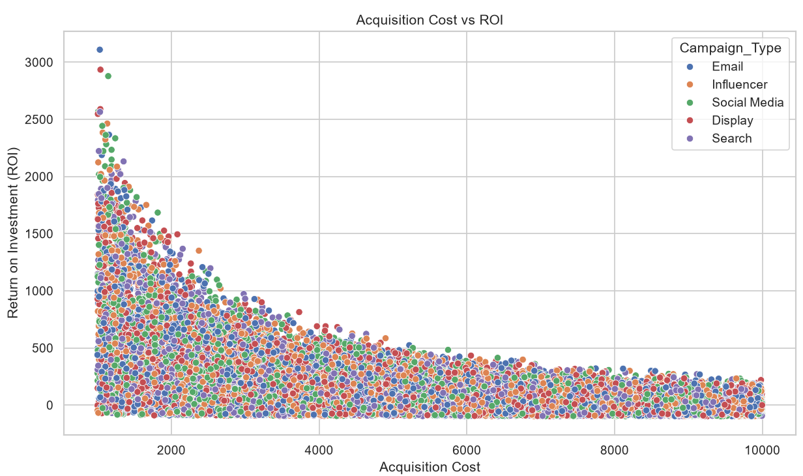
OUTPUT 6.2) BAR CHART - AVERAGE CONVERSION RATE BY CHANNEL
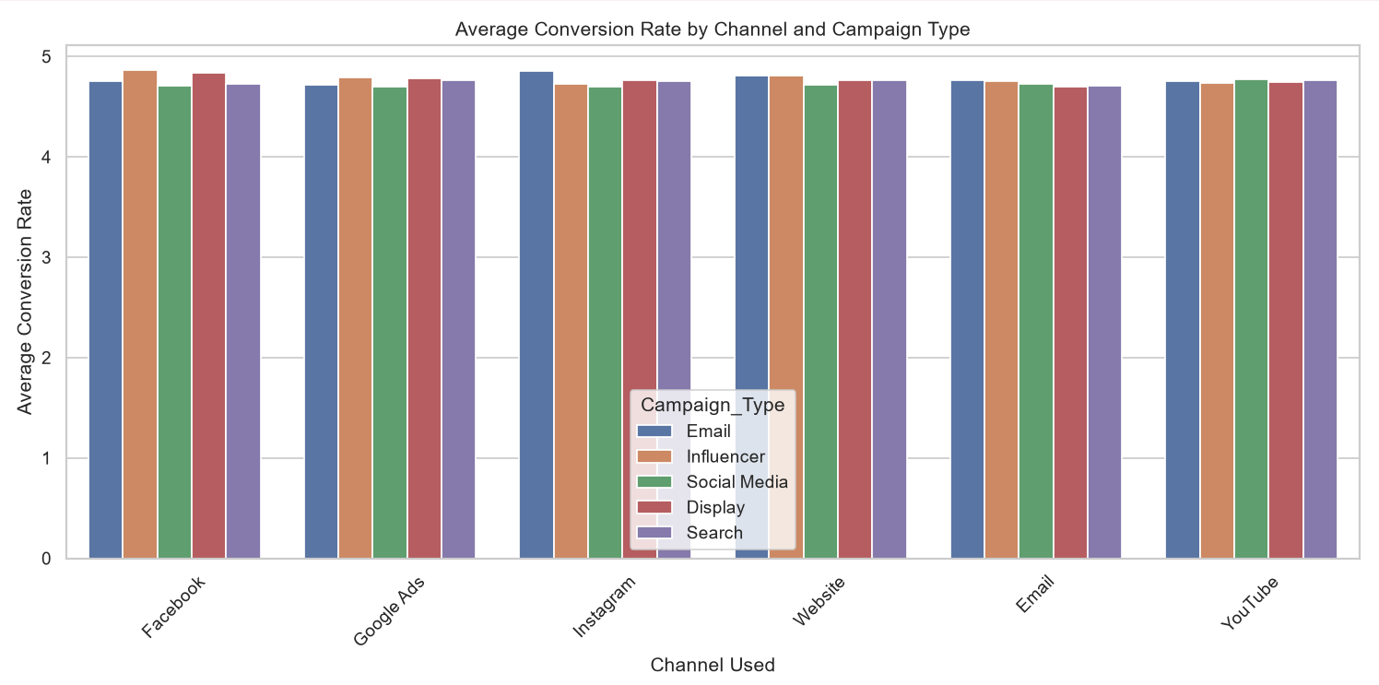
OUTPUT 6.3) BOX PLOT - ENGAGEMENT SCORE BY CAMPAIGN TYPE
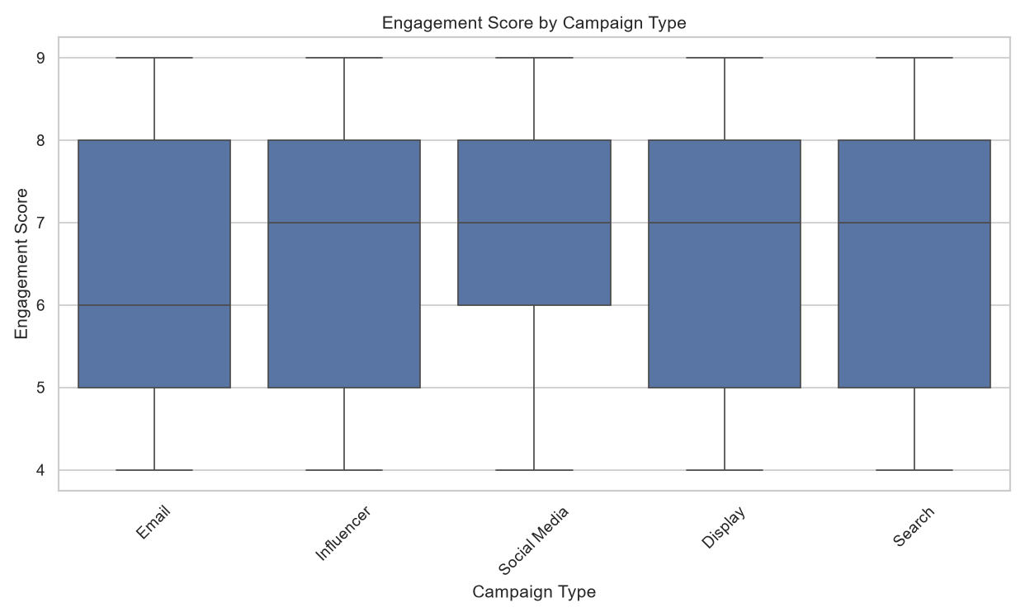
OUTPUT 6.4) BAR CHART - AVERAGE ROI BY COMPANY
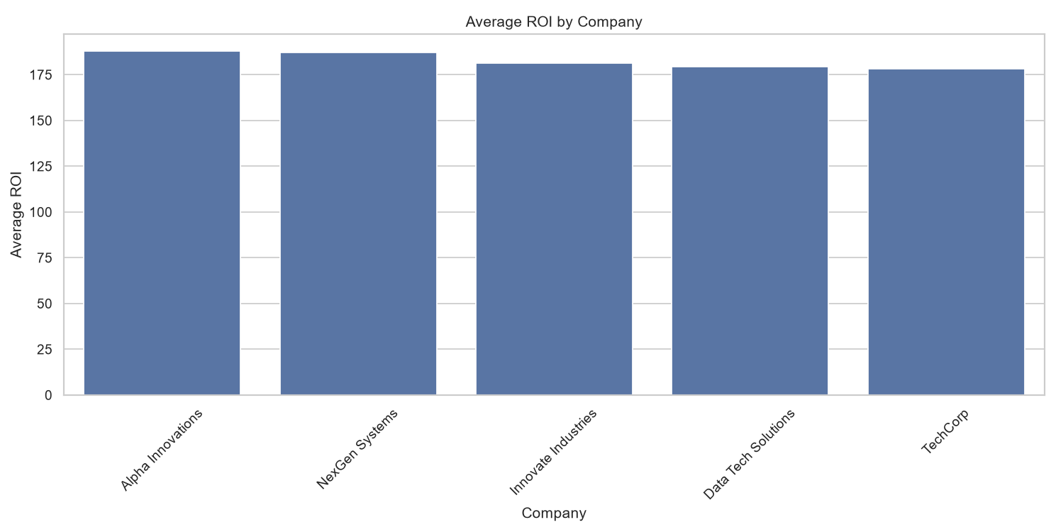

OUTPUT 6.5) HEATMAP - ENGAGEMENT SCORE AND CONVERSION RATE
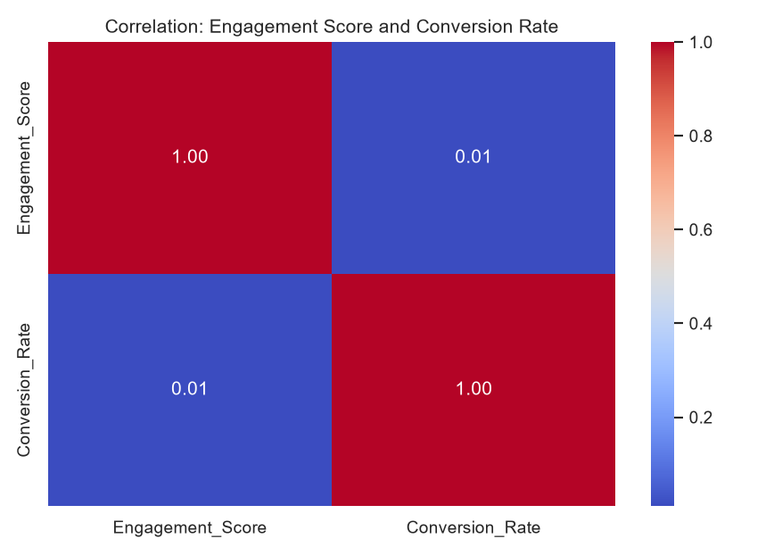
OUTPUT 7.1) COUNT PLOT - TARGET AUDIENCE DISTRIBUTION
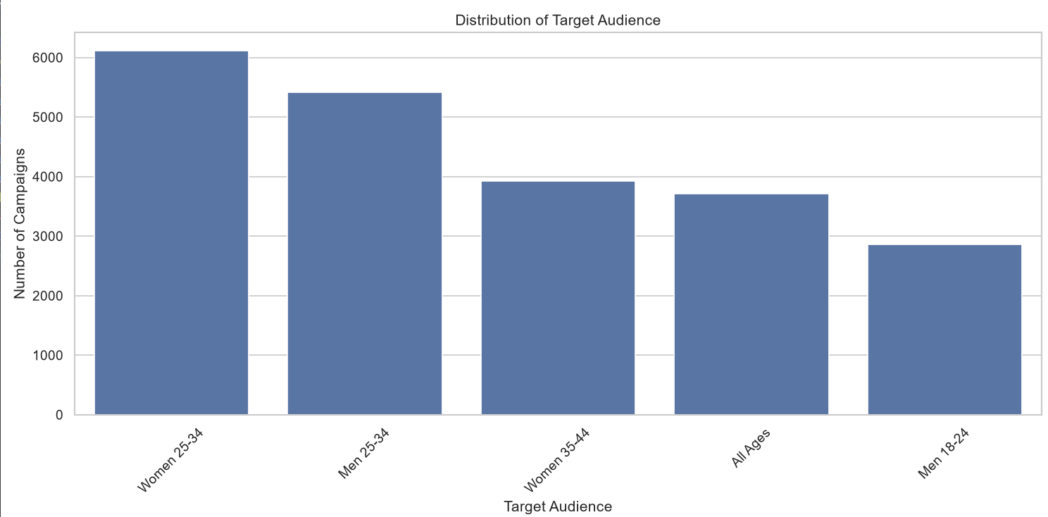
OUTPUT 7.2) BAR CHART - CUSTOMER SEGMENT CONVERSION RATE BY LANGUAGE
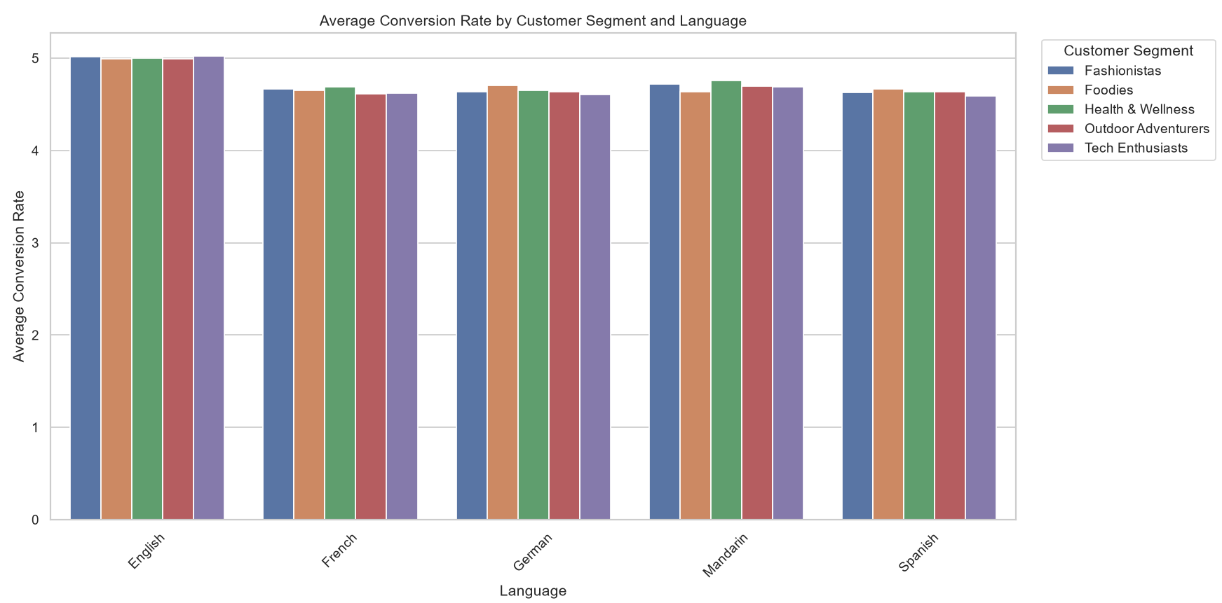
OUTPUT 7.4) BOX PLOT - ACQUISITION COST BY CUSTOMER SEGMENT
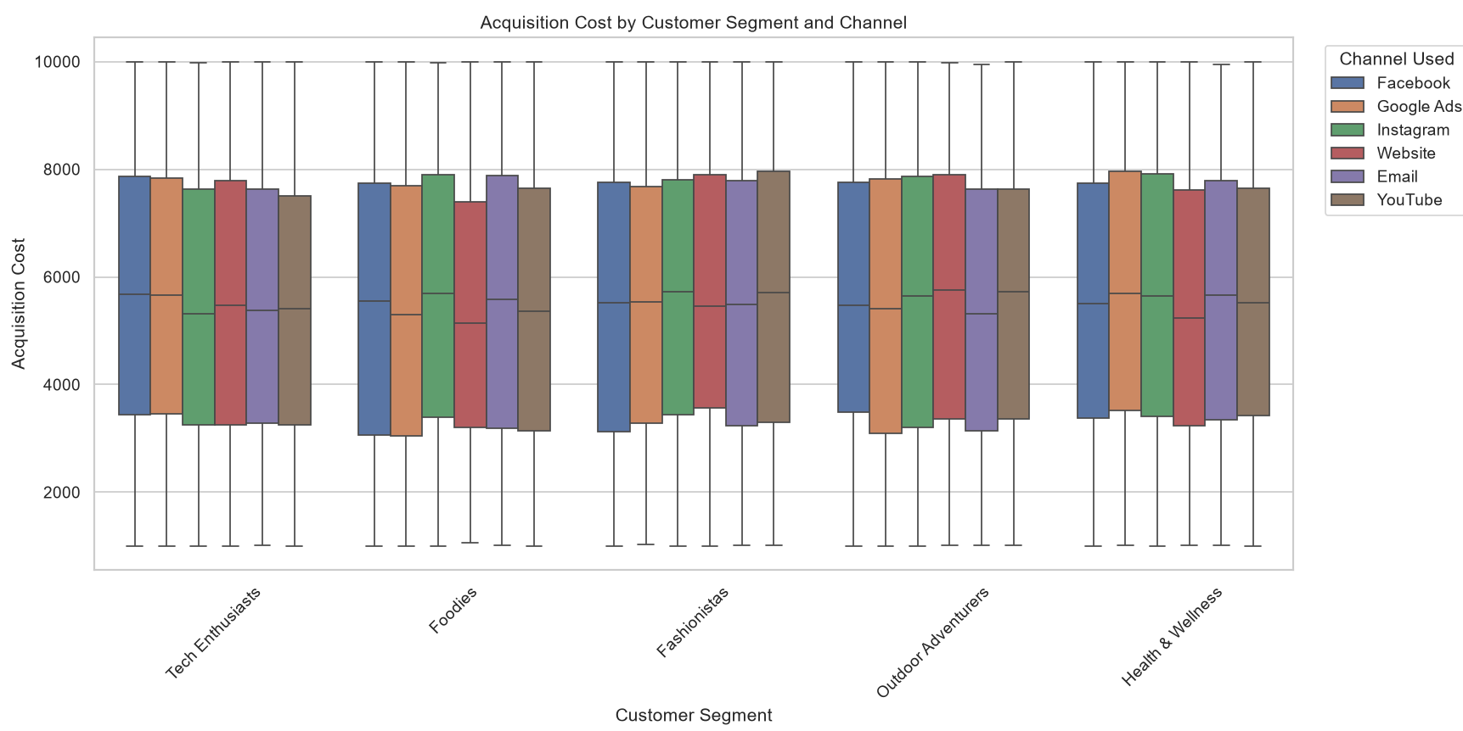
OUTPUT 7.5) BAR CHART - AVERAGE CONVERSION RATE BY LANGUAGE
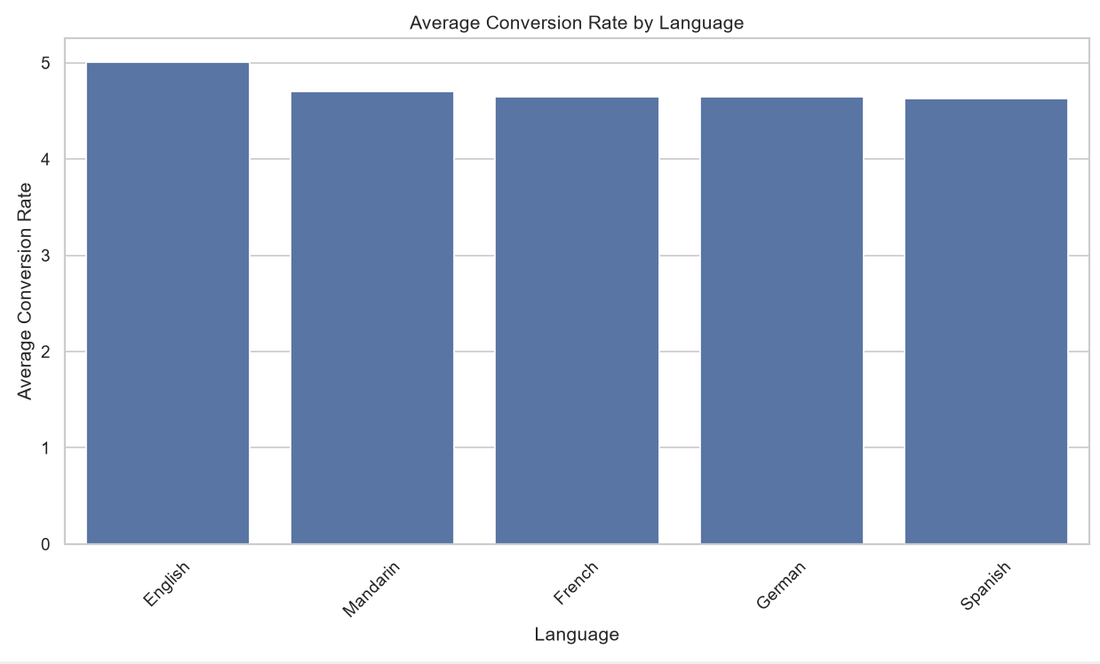

OUTPUT 8.1) BAR CHART - ENGAGEMENT SCORE BY CHANNEL
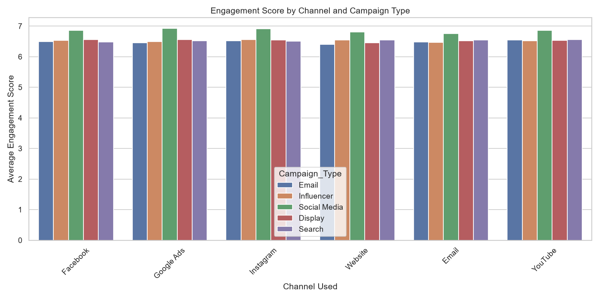
OUTPUT 8.2) PIE CHART - TOTAL ROI BY CHANNEL
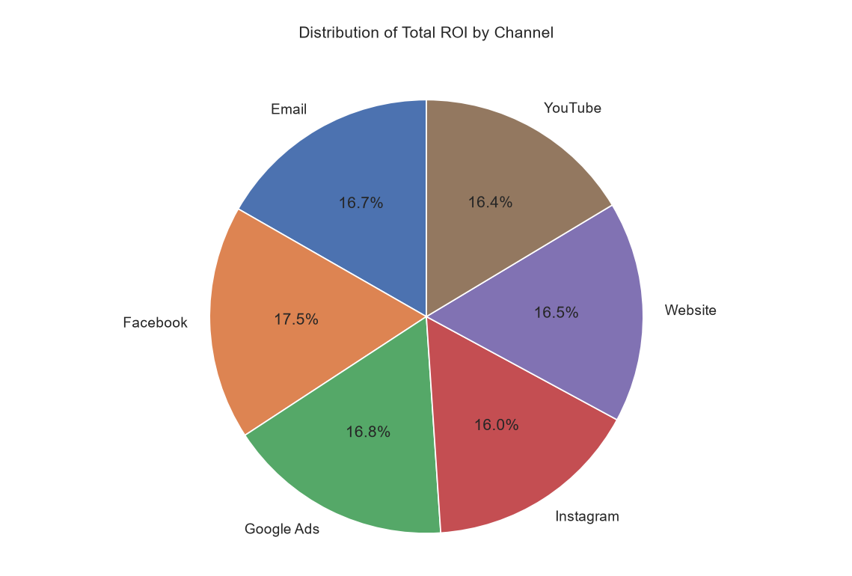
OUTPUT 8.3) SCATTER PLOT - CLICKS VS IMPRESSIONS BY CHANNEL
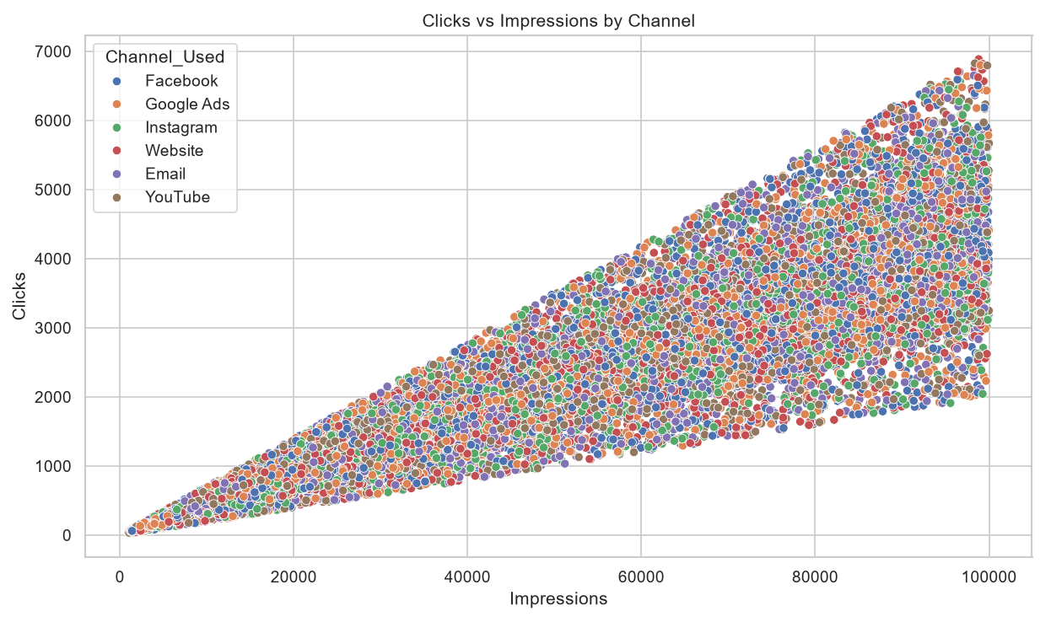
OUTPUT 9.1) HISTOGRAM - CAMPAIGN DURATION DISTRIBUTION
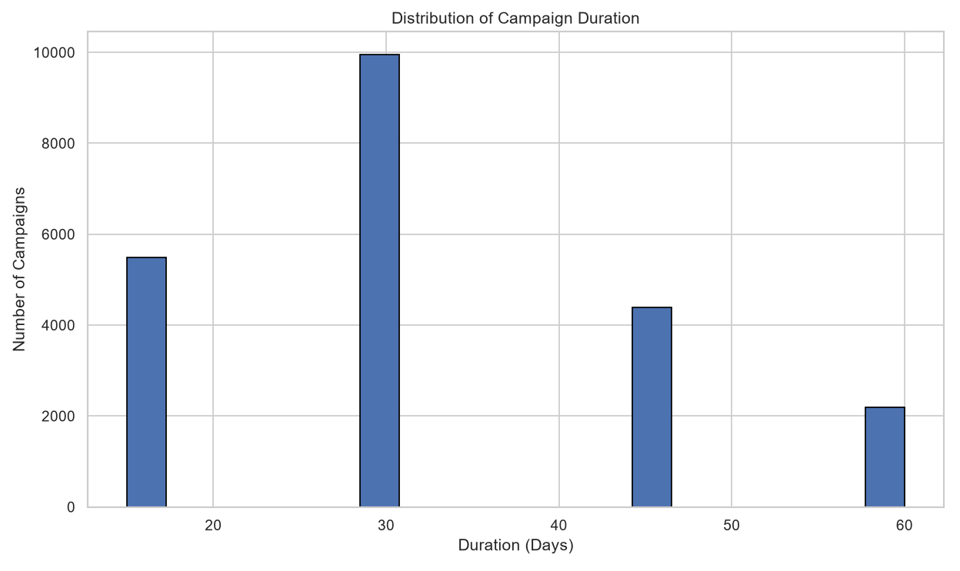
OUTPUT 9.2) LINE CHART - CONVERSION RATE OVER DATE BY COMPANY
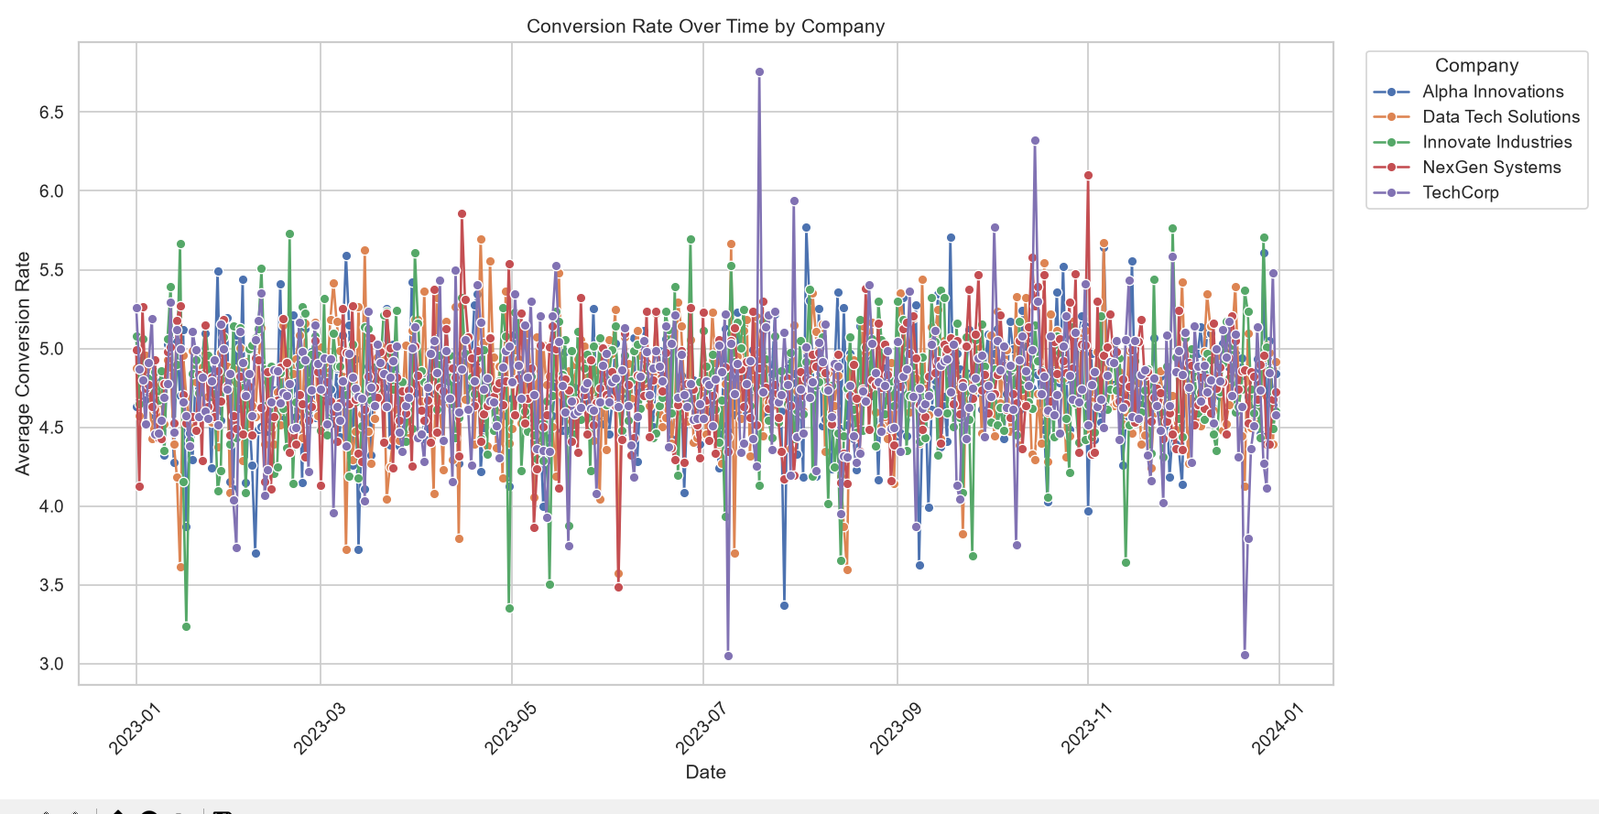
OUTPUT 9.3) LINE CHART - ENGAGEMENT SCORE OVER DATE
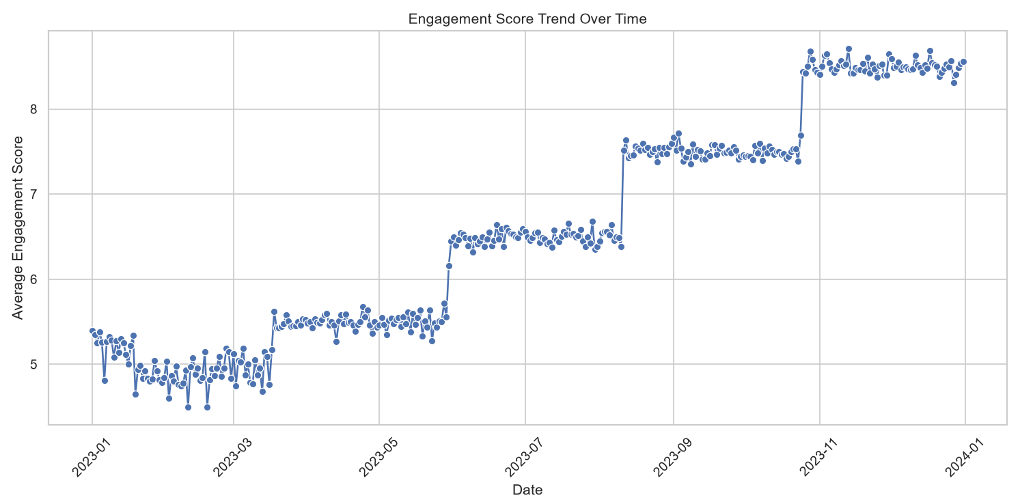
OUTPUT 10.1) BAR CHART - ACQUISITION COST BY LOCATION
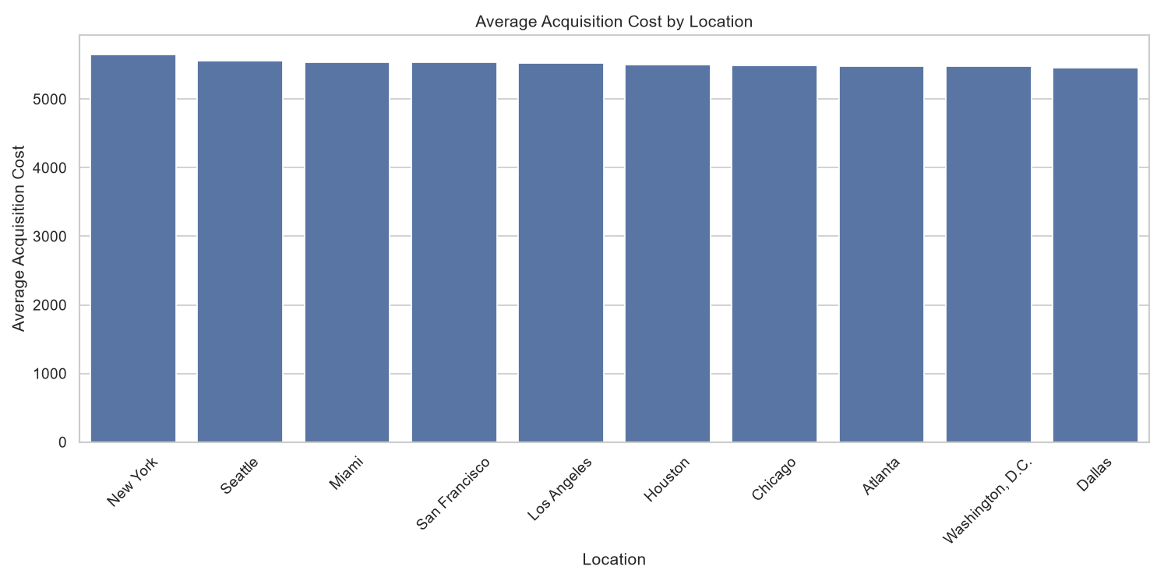
OUTPUT 10.2) BAR CHART - CONVERSION RATE BY LOCATION
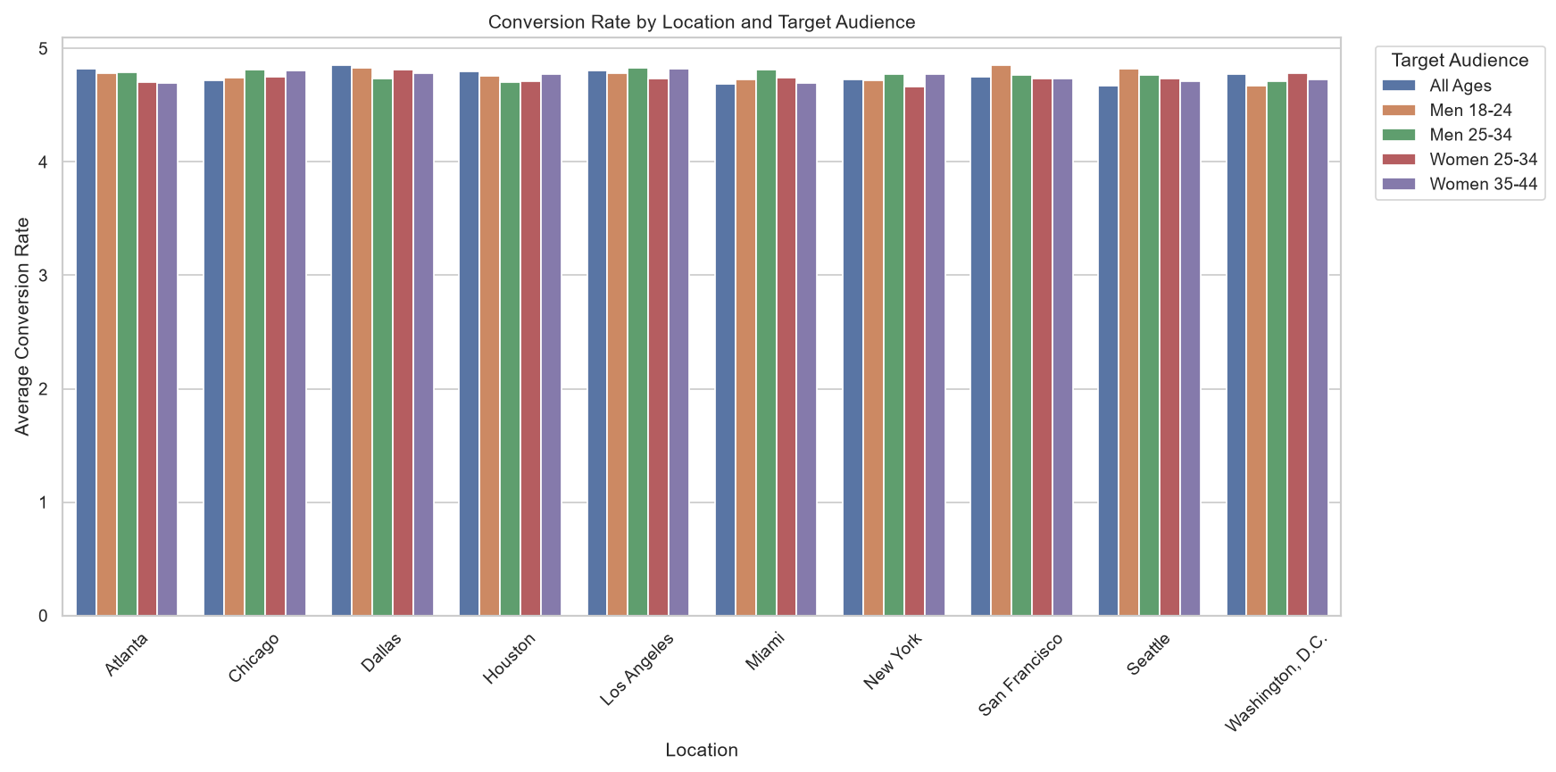
OUTPUT 10.3) PIE CHART - PROPORTION OF ROI BY LOCATION
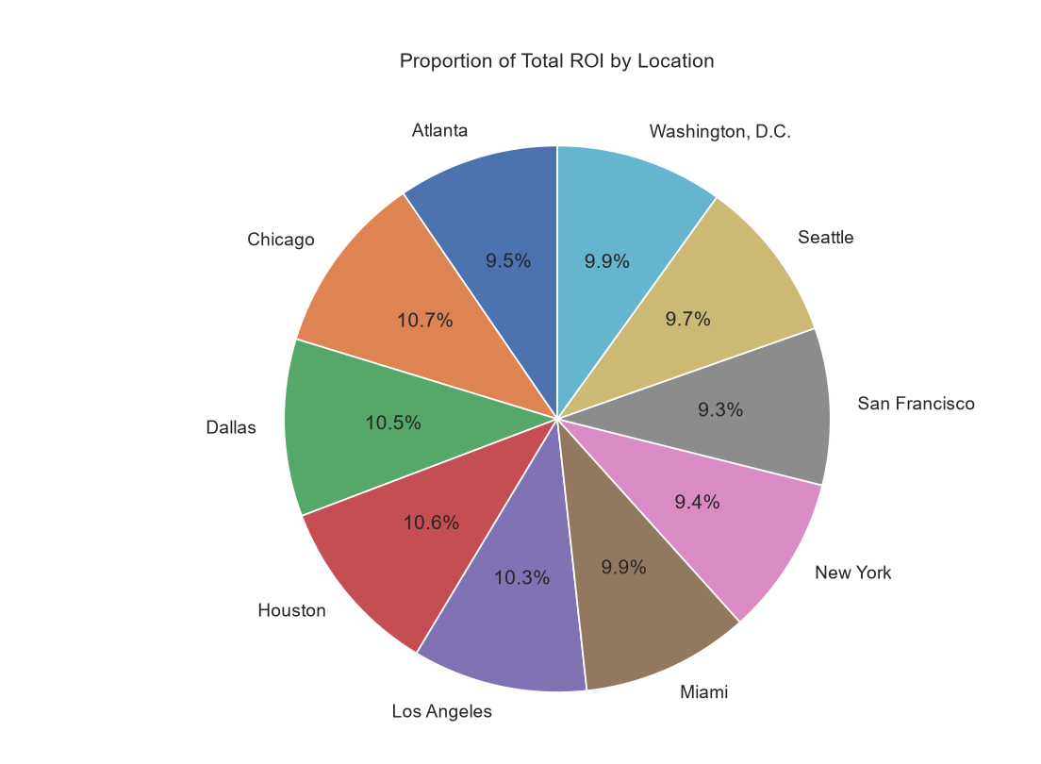

PROGRAM OUTPUT (TERMINAL)
========== DATASET LOADED SUCCESSFULLY ==========

Campaign_ID Company Campaign_Type Target_Audience ... Impressions Engagement_Score Customer_Segment Date
0 1 TechCorp Email Women 25-34 ... 67836 5 Tech Enthusiasts 01-01-2023
1 2 Innovate Industries Influencer Women 35-44 ... 66361 4 Foodies 01-01-2023
2 3 NexGen Systems Social Media Women 25-34 ... 86240 8 Fashionistas 01-01-2023
3 4 Innovate Industries Email Women 25-34 ... 58251 6 Foodies 01-01-2023
4 5 Data Tech Solutions Influencer Men 25-34 ... 34407 5 Tech Enthusiasts 01-01-2023

[5 rows x 16 columns]

========== FIRST 5 ROWS ==========

Campaign_ID Company Campaign_Type Target_Audience ... Impressions Engagement_Score Customer_Segment Date
0 1 TechCorp Email Women 25-34 ... 67836 5 Tech Enthusiasts 01-01-2023
1 2 Innovate Industries Influencer Women 35-44 ... 66361 4 Foodies 01-01-2023
2 3 NexGen Systems Social Media Women 25-34 ... 86240 8 Fashionistas 01-01-2023
3 4 Innovate Industries Email Women 25-34 ... 58251 6 Foodies 01-01-2023
4 5 Data Tech Solutions Influencer Men 25-34 ... 34407 5 Tech Enthusiasts 01-01-2023

[5 rows x 16 columns]

========== NUMBER OF ROWS AND COLUMNS ==========

(22029, 16)

========== COLUMN NAMES ==========

Index(['Campaign_ID', 'Company', 'Campaign_Type', 'Target_Audience',
'Duration', 'Channel_Used', 'Conversion_Rate', 'Acquisition_Cost',
'ROI', 'Location', 'Language', 'Clicks', 'Impressions',
'Engagement_Score', 'Customer_Segment', 'Date'],
dtype='str')

========== DATA TYPES ==========

Campaign_ID int64
Company str
Campaign_Type str
Target_Audience str
Duration str
Channel_Used str
Conversion_Rate float64
Acquisition_Cost int64
ROI float64
Location str
Language str
Clicks int64
Impressions int64
Engagement_Score int64
Customer_Segment str
Date str
dtype: object

========== DATASET INFORMATION ==========

<class 'pandas.DataFrame'>
RangeIndex: 22029 entries, 0 to 22028
Data columns (total 16 columns):
# Column Non-Null Count Dtype
--- ------ -------------- -----
0 Campaign_ID 22029 non-null int64
1 Company 22029 non-null str
2 Campaign_Type 22029 non-null str
3 Target_Audience 22029 non-null str
4 Duration 22029 non-null str
5 Channel_Used 22029 non-null str
6 Conversion_Rate 22029 non-null float64
7 Acquisition_Cost 22029 non-null int64
8 ROI 22029 non-null float64
9 Location 22029 non-null str
10 Language 22029 non-null str
11 Clicks 22029 non-null int64
12 Impressions 22029 non-null int64
13 Engagement_Score 22029 non-null int64
14 Customer_Segment 22029 non-null str
15 Date 22029 non-null str
dtypes: float64(2), int64(5), str(9)
memory usage: 2.7 MB

========== DESCRIPTIVE STATISTICS ==========

Campaign_ID Conversion_Rate Acquisition_Cost ROI Clicks Impressions Engagement_Score
count 22029.000000 22029.000000 22029.000000 22029.000000 22029.000000 22029.000000 22029.000000
mean 11015.000000 4.757232 5522.740842 182.863648 2223.807572 50610.402787 6.582323
std 6359.368876 0.960393 2597.666260 301.619721 1394.166380 28542.979123 1.458804
min 1.000000 2.015723 1000.000000 -98.300000 30.000000 1001.000000 4.000000
25% 5508.000000 4.130705 3286.000000 -4.080000 1067.000000 25804.000000 5.000000
50% 11015.000000 4.761527 5525.000000 93.650000 2088.000000 50858.000000 7.000000
75% 16522.000000 5.429335 7766.000000 247.310000 3212.000000 75165.000000 8.000000
max 22029.000000 7.469907 9999.000000 3109.790000 6887.000000 99999.000000 9.000000

========== UNIQUE CAMPAIGN IDs ==========

22029

========== UNIQUE LOCATIONS ==========

<StringArray>
[ 'Houston', 'Washington, D.C.', 'Miami',
'Seattle', 'Chicago', 'Los Angeles',
'Atlanta', 'Dallas', 'New York',
'San Francisco']
Length: 10, dtype: str

========== UNIQUE CUSTOMER SEGMENTS ==========

<StringArray>
[ 'Tech Enthusiasts', 'Foodies', 'Fashionistas',
'Outdoor Adventurers', 'Health & Wellness']
Length: 5, dtype: str

========== CAMPAIGN TYPE COUNTS ==========

Campaign_Type
Display 4450
Search 4441
Social Media 4412
Email 4388
Influencer 4338
Name: count, dtype: int64

========== CHANNEL COUNTS ==========

Channel_Used
Facebook 3742
Google Ads 3694
Website 3688
Instagram 3649
YouTube 3632
Email 3624
Name: count, dtype: int64

========== DATA CLEANING COMPLETED ==========

Campaign_ID 0
Company 0
Campaign_Type 0
Target_Audience 0
Duration 0
Channel_Used 0
Conversion_Rate 0
Acquisition_Cost 0
ROI 0
Location 0
Language 0
Clicks 0
Impressions 0
Engagement_Score 0
Customer_Segment 0
Date 0
dtype: int64

Cleaned Dataset Shape:
(22029, 16)

========== BEST CUSTOMER SEGMENT BY LANGUAGE ==========

Language Customer_Segment Conversion_Rate
4 English Tech Enthusiasts 5.022731
7 French Health & Wellness 4.689704
11 German Foodies 4.705430
17 Mandarin Health & Wellness 4.756125
21 Spanish Foodies 4.663610

Location with Highest Average Acquisition Cost:
New York

==============================================
MARKETING CAMPAIGN ANALYSIS REPORT
==============================================

Total Number of Campaigns:
22029

Number of Unique Campaigns:
22029

Average Conversion Rate:
4.76

Average Acquisition Cost:
5522.74

Average ROI:
182.86

Average Engagement Score:
6.58

Campaign Type with Highest Average ROI:
Social Media

Company with Highest Average ROI:
Alpha Innovations

Channel with Highest Average Conversion Rate:
Facebook

Location with Highest Average Acquisition Cost:
New York

Customer Segment with Highest Average Conversion Rate:
Health & Wellness

